# 1. The Rise of the Network Commons

The Rise of the Network Commons returns to the topos of the wireless commons on which I worked during the early 2000s. In this new version, combining original research from my German book *Freie Netze*[1] (2004) and new research conducted in the context of the EU funded project *Confine*[2] (2012-2015), the exciting world of wireless community network projects such as Guifi.net and Freifunk, Berlin, gets interspersed with philosophical reflections on the relationship between technology, art, politics, and history.

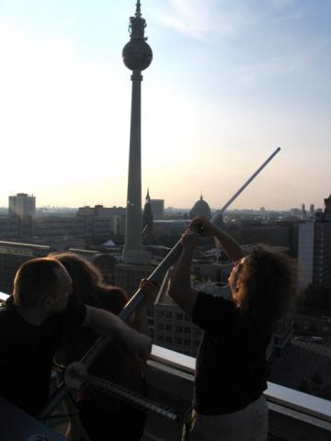Fig. 1. Antenna installation at Haus des Lehrers, 2003. Image courtesy Freifunk.

## 1.1 The World of Guifi.net and the Dispositif of Network Freedom

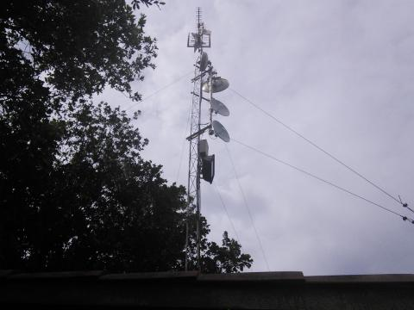Fig. 2. Guifi antenna.

On my recent visit to Barcelona in the context of the Confine project, Guifi.net founder Ramon Roca took me to Gurb, the village he comes from. There, in 2003 Guifi.net was started when Ramon realized that he would never get good bandwidth at a fair price in this remote area in sight of the foothills of the Pyrenees. Ramon, who is an IT professional but keeps his working life and activities with Guifi.net separated, found that he could get broadband by using WLAN to connect to a public building in the outskirts of a nearby small town, Vic. Since then, Guifi.net has grown to become the largest WLAN community network in Europe, with currently more than 25,000 nodes. It is not entirely correct anymore to call it a wireless community network since a growing number of nodes are created by fibre-optic cable. Since Ramon and his cooperators have found out how relatively easy it is to work with fibre, he is on a new mission to get fibre to the curb to as many houses as possible.

Visiting Gurb and talking to Ramon for nearly a full day has revitalized my fascination for wireless (and wired) community networks. I have written a book on wireless community networks in 2003, in German, under the title *Freie Netze* (Free Networks).[3] The choice of title back then had deliberately emphasized the analogy between Free Networks and Free Software. The title had been inspired by two very different influences. On one hand there had been Volker Grassmuck’s early book Freie Software.[4] Volker’s magisterial work provided deep insight into the history and politics of Free Software and stood out for me as an example how a book on wireless community networks should be written. The other inspiration had been provided by a sweeping lecture in Vienna in June 2003 by Eben Moglen, lawyer of the Free Software foundation and legal brain behind the licensing model of Free Software, the GNU General Public License (GPL[5]). Moglen’s thunderous and captivating speech had presented the combination of Free Software, Free Hardware and Free Networks like a kind of holy trinity of the everything-free-and-open movement. Moglen’s conclusion was that while Free Software was already an accomplished fact and free hardware was the hardest bit, free networks were a viable possibility, yet there was still a long way to go to attain critical mass.

My book had come maybe a few years too early. When it appeared, some of the most important wireless community networks of today, such as Freifunk, Berlin, Funkfeuer, Austria, or Guif.net, were either non existent or existed in embryonic form only. The model of wireless community networks on which my book had been based had been created by Consume.net in the UK. Consume.net was the outcome of an improvised workshop in December 1999 in Clink Street, near London’s creative net art hub Backspace. I will describe the history of Consume in more detail below, but one key aspect of that initiative was that it was launched by non-techies. James Stevens, founder of Backspace, and Julian Priest, artist-designer-entrepreneur, provided the impetus for DIY wireless networking by sketching plans for a *Model 1* of WLAN-based community networking on a napkin during a tempestuous train journey in late summer 1999. Their *Model 1* – a name chosen for its association with Henry Ford’s first mass-produced car, the Ford Model 1 or Tin Lizzy – was a techno-social network utopia.

The relatively young discipline of science studies teaches us that the technical and the social cannot or should not be considered as categorically separated. *‘*Technologies are socially produced’ is one of the key phrases in the discourse of science studies. They do not exist outside the human world but are the product of specific societies which exist under specific conditions and circumstances. Technologies are hybrids between nature and society, as science studies author Bruno Latour puts it. Moreover, a specific school of science studies, the Social Construction of Technological Systems (SCTS) has studied the co-evolution of large technological systems and social structures. SCTS pioneer Thomas P. Hughes, who studied the building of the first nationwide electrical grid, has found that there are strong co-dependencies between technological and social systems. While there is undeniably a strong influence on the shaping of technologies exerted by business interests, Hughes’ work emphasizes co-dependencies between technologies and the people who build and maintain them, the technologists or techies – a term I will use from now on because it allows to refer to both academic computer scientists and researchers and autodidactic hackers, whereby I hope my use of the term is not seen as derisive in any way.

Engineers and skilled workers involved in large technological projects bring certain predispositions to projects. As projects evolve, the communities of techies develop certain habits and ways of working. The technological and social system build a unity which determines the ways how those technologies evolve in the future. What we can learn from science studies is that neither is science objective (in the strict sense of the word), nor is technology neutral. To believe the opposite would either constitute scientific objectivism – a rather outdated form of scientific positivism – or technological determinism, which is the belief that technology alone is the main factor shaping social developments.

James Stevens and Julian Priest, founders of Consume, are neither scientific positivists nor technological determinists. They conceived Model 1 as a techno-social system from the very start. Their ideas combined aspects of social and technological self-organization. In tech-speak, the network they aimed at instigating was supposed to become a Wide Area Network (WAN). But while such large infrastructural projects are usually either built by the state or by large corporations, James and Julian thought that this could be achieved by bottom-up forms of organic growth.

Individual node owners would set up wireless network nodes on rooftops, balconies and window sills. Each node would be owned and maintained by its owner, who would also define the rules of engagement with other nodes. The network would grow as a result of the combination of social and urban topologies. The properties of the technology – well strictly speaking there is no such thing as property of technology as I just explained but lets reduce complexity for a moment – impose certain restrictions. WLAN (Wireless Local Area Networking), later called Wi-Fi by the trademark of the Wi-Fi Alliance, operates in a part of the electromagnetic spectrum that does not pass through obstacles such as walls. Therefore, from one node to the next there needs to be an uninterrupted line-of-sight. Node-owners need a way of identifying each other in order to create a link. According to the properties of internetworking protocols each of those links is a two-way connection, which means that data can travel as easily in one direction as in the other. Furthermore, node owners would agree to allow data to pass through their nodes. There would not only be point-to-point connections from one node to the other, but larger networks, where data can be sent and received via several nodes. Such a wide area community network would also have gateways to the internet in order to allow exchange of information between the local wireless community network and the wider networked world.

Those desired characteristics of Model 1 were not actually invented by Julian and James. Those properties already existed, deep inside the technologies we use to connect, but working for most parts unnoticed by those who use them. The key term has already been introduced above, without further explanation, it is the *protocols* that govern the flow of information in networked communication structures. Protocols are conventions worked out between techies to decide how the flow of data in communication networks should best be organized. The basic protocols on which the Net is running, such as the Internet Protocol (IP) and the Transport Control Protocol (TCP) have been defined decades ago by engineers and computer scientists working on the precursors of the Net, Arpanet and NSF-net. Some people would go as far as saying that the internet is neither the actual physical structure of cables and satellites used to connect, nor the content that travels via such structures but it is embodied in the suite of protocols, commonly referred to as TCP/IP (those two are usually mentioned but there are many more). The protocols are the essence of the Net because they give it its key characteristics. I am not sure if this is not a very refined form of technological determinism, but I would like to leave this question open for a moment.

The reason for this hesitation is that the protocols are not identical with the technology that uses them. The protocols are conventions that can be described in textual form. The way how this is done is through so called Requests for Comments (RFCs). Since the dawn of the Net, RFCs have been defined in a way that runs counter to common understandings of how technologies are created. RFCs are approved by techies who congregate under the umbrella of the Internet Engineering Task Force (IETF). The arcane decision making mechanisms of the IETF have since the very start been governed by maxims such as ‘rough consensus and running code’. People who develop new internet technologies present them to their peers who then react by making noises such as humming or whistling. Criteria for approval are not theoretical consistency but whether they actually do something or not. The robustness and the freedom of the Net is guaranteed, despite the lack of central coordination, by the self-organized decision making power of those techies who meet at the IETF. While a lot of those people may have jobs with large corporations, when they meet at IETF conferences they still decide as technicians who adhere to their own codes of human responsibility.

It is amazing because, despite the commercialization of the Net, this has not fundamentally changed. Corporations and governments may seek to wrest more and more control over the net, and while they are actually quite successful in doing so in some areas, the social protocols of decision making enshrined in the mores of the techno-social communities have so far been able to withstand all such assaults. On the layer of the protocols the Net was and is still *free*.

Thus, when James and Julian wrote out the formula of growth for Model 1, they referred to a freedom to connect that is inherent to the way in which the internet was originally conceived and still functions now, on the layer of the protocols. The knowledge and awareness of that fact had become buried by new layers built on top of older layers in the course of technological improvement but also the commercialization of the Net in the 1990s. Consume.net was started at the cusp of what was then called the New Economy, a stock exchange boom fueled by the rise of information and communication technologies in general and PCs and the internet in particular. The 1990s had been a very exciting decade which saw the rise from obscurity of the Net from a communication technology used by scientists and a small number of civil society organizations, artists and freaks in the late 1980s, early 1990s, to a widely used medium driving and being driven by a gigantic economic machinery. In the process, a lot of the properties that had been dear to the early inhabitants of the Net, the digital natives, had become either sidelined or overshadowed by commercially driven interest and the secret workings of the deep state.

Model 1 was thus both a new techno-social invention but also a recurse to the original Internet Arcadia. Against the tide of rising commercialization and the inequalities and distortions that came with it, wireless community networks were supposed to bring back a golden age of networked communication, of equality and freedom. Technical and social properties were conflated into a model of self-organization. The possibility for that was provided by a small and often overlooked feature of the technology. 802.11b was the technical name of the wireless network protocol as used at about 1999. It allowed two different operating modes, one where each wireless network node knew its neighbors and could receive and send data based on fixed routing tables, and another one, the ad-hoc mode, where nodes would spontaneously connect with each other. The ad-hoc mode was supported by routing protocols that are best suited for the wireless medium. In a fixed network with cables, it is of advantage to work with fixed routing protocols. When data arrives, the network node decides where to send it, based on its knowledge of the topology of the network. But in wireless networks that topology constantly changes. Nodes can break down due to atmospheric or environmental influences. The quality of connection can change dramatically because of disturbances in the electromagnetic medium. Or a truck parks in front of your house and the line-of-sight is suddenly gone.

For this reason, Consume.net started to get interested in a technology called mesh networking. In the year 2000 mesh network protocols were still very much in their infancy. There was a working group called Mobile Ad-hoc Networking (Manet), supported by the US military. In Germany, a small company was building something called MeshCube.[6] It was a working technology but it was not really open source and only the developer knew how to run it. When Consume.net started to work with mesh network technology, this seemed to be a utopian technology. While neither James nor Julian were techies, they had the support of some very skilled hackers, but neither of them was capable of significantly developing mesh network protocols. Mesh networking was a dream, something that was already on the horizon but not yet there.

This was a pattern established in 2000 and still very much in place in the year 2014: when the problems of mesh networking would be solved, wireless community networks would flourish and become unstoppable. Social qualities, such as self-organization without centralized forms of control, were mapped onto technological properties, such as the ability of machines to automatically recognize each other and connect to build a larger cloud of networked nodes. The idea of network freedom – the ability to connect without having to apply to a central point of governance and without having to go through a company such as a telecommunications operator (telco) – was supposed to further communication freedom and thus the rights and ability of people to express themselves and communicate freely without top-down hierarchical control. The convergence of those ideas I call the dispositif of mesh networks and network freedom.

I am appropriating the term *dispositif* from Michel Foucault who used it to ‘refer to the various institutional, physical, as well as administrative mechanisms and knowledge structures which enhance and maintain the exercise of power within the social body.’[7]

Our mesh network dispositif does not (yet) add up to all society, but it is something that is widely shared among techies building wireless community networks. It is a discursive behavior, but also a set of beliefs and a set of material assemblages. *Assemblage* is another term that I appropriate freely from a French philosopher, Gilles Deleuze. While the dispositif does not exist outside time, it is somehow hovering above the concrete historical moment. In this way, the dispositif of mesh networks has influenced wireless community networks since the year 2000. The assemblage, while also consisting of material and non-material components, is concretely manifest in the historical moment. The mesh network dispositif promises to bring about an era of unrestricted and seamless communication, free from technological and social constraints. This dispositif historically legitimates itself by the way the internet was originally conceived. At the same time it contains the promise of a future when the Net will be again what it once had been.

When I came to Barcelona in July 2014, I was thrilled to see that as part of the EU funded research project Confine a project was under way to develop the Quick Mesh Project (QMP). QMP is a so called free firmware, a GNU/Linux based operating system for network devices. Many people now have wireless routers at home. When you buy internet access from a provider, you often also get a box that allows to wirelessly connect to the Net. QMP would replace the operating system of such a device with a much improved version, one that speaks the language of mesh network protocols. To give a simple example, if in a street of apartment blocks everybody who owns a wireless router replaces the firmware with QMP and puts the router on the window sill, all those machines would automatically connect and build a network without using any cables or other hardware from commercial providers. It would make it easy and simple to connect without having to go deep into system settings. This has now changed from being a faraway utopian goal to something that is literally around the corner.

It may or may not succeed. One problem with that is that it resembles what Saskia Sassen described as an engineer’s utopia. Techies, whether they are academically trained computer scientists, telecommunications engineers or self-taught hackers, tend to believe in the unlimited potential of technology. They see the potential of a technology. There is nothing that speaks against it, on the contrary. It needs such people who are capable of dreaming a different future based on creative bending and twisting of technologies. The problem, however, is that far-sighted techies tend towards a linear extrapolation of technologies into the future without considering other factors, such as politics, the economy, the fundamental differences between people in class-based societies and so on and so forth. In this way, the highly productive mesh network dispositif gets turned into the dreamworld of the internet cornucopia. The technology gets imbued with characteristics that are actually outside of it and depend on factors beyond the influence of creative technologists. It becomes a messianic technology in the way the great philosopher of culture and technology Walter Benjamin theorized it in the 1930s.

## 1.2 Dawn of an Idea

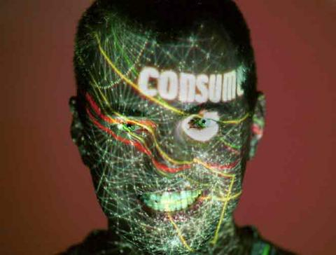Fig. 3. James Stevens with projection of network topologies.

Good ideas often pop up at the same time at various points on the Earth, they just seem to be in the air. And so it came that around the year 2000 at different points on the globe wireless free community networks were started: Consume.net in London, New York Wireless, Seattle Wireless, and Personal Telco, in Portland Oregon, were among the first wireless community networks based on Wireless LAN, or WLAN. Nobody really can say which one came first. I have been lucky to experience the development of Consume and free2air.org in London from a close encounter. Therefore, in this chapter I will tell the story of those networks.

But before I go into the details of this story, it is worth remembering a bit how things were back then. Today, when the debate shifts to a topic such as so called digital natives, many young people seem incapable of comprehending that there are middle-aged people like me who have spent a large part of their adult life on-line. I had my first computer in 1985, whereby I should say *we*, because it was a shared computer between my then girlfriend and myself. In 1989 it was followed by two new computers. She got an Amiga 2000, and I got a pre-Windows PC. So I spent a good time learning key commands for the DOS version of Word, while my partner could do wonderful graphical stuff on her Amiga. We could even digitize video, change every single image and turn it into a loop that could be played out and recorded to tape. While I was envious of the slick graphical interface of the Amiga, my PC soon learned a new skill, communication with other computers. That was when the whole on-line fun started.

Actually, we had to overcome a few obstacles first. In Europe, computer modems at the time – around the late 1980s to the early 1990s – had to be licensed by the national postal, telegraph and telephone service (PTT). This made the stuff prohibitively expensive for many. But we found a workaround. We traveled to West-Berlin and there, in a store called A-Z Electronics, we could buy a 2400 baud modem on the cheap. This modem could be legally sold because it had one cable missing – a loophole in German law according to which it was legal to sell unlicensed equipment if it was not in a state to be used. After we smuggled it back to Vienna, we soldered in the cable and connected the modem to the phone line. Franz Xaver, a friend and artist-engineer, had to help to solve issues with the arcane Austrian telephone system. Another friend brought a pack of diskettes and we installed Telix, a programme for communicating with bulletin board systems (BBS).

The BBS world was like a testing ground for virtual communities where certain types of behavior could form. This could be elements of a netiquette, but also an understanding of what it means to be on-line in the first place. Stories about early on-line communities by authors such as Sandy Stone[8] and Howard Rheingold[9] describe how these communities, some of which go back to the early 1970s, foster social (or anti-social ;-) behaviour.

First artistic experiments with *Art and Telecommunication*[10] began in the late 1970s. The Canadian artist Robert Adrian X, who by then was living in Vienna, started an artist’s conference board called Artex on a proprietary network in 1980. Fellow artist Roy Ascott described in vivid terms how it felt to be on-line and engage in real-time synchronous communication.

Over the past three years I have been interacting through my terminal with artists in Australia, Europe, and North America, once or twice a week through I.P. Sharp’s ARTBOX. I have not come down from that high yet and frankly I don’t expect to. Logging in to the network, sharing the exchange of ideas, propositions, visions and sheer gossip is exhilarating. In fact it becomes totally compelling and addictive.[11]

Similar feelings have been shared by almost everyone who experienced an always-on network connection. But let us return to the BBS world, which could be quite wild at times. Artists-hackers such as Toek from radio art and performance group DFM circumvented the fact that those systems did not really have graphical interfaces by creating a log-on page with flashing and blinking ASCII animations. Communications in those systems were uncensored – apart from the curiosity of the maintainer of the system – and sometimes one could encounter, without looking for it, cracked software or literature such as the *Hackerfibel* by the Chaos Computer Club, or the Anarchist Hackers Cookbook, or The Temporary Autonomous Zone by Hakim Bey; one could also find software for war-dialing and similar things bordering on what was legally permissible. This BBS content led to promote the myth that the internet itself is a haven for radical illegal content with dark corners of countless publicly available DIY bomb-building manuals.

This is a pretty persistent myth by the way, but has maybe more to do with the criminalization of hacking by the US secret services who seemed to be intent on demonizing an activity that many of those involved understood primarily as curiosity, research, interest, gaining new knowledge. When the internet was opened up for public usage, it seemed to get populated very quickly by all kinds of creative spirits. In 1995, when I had, through work, my first always on *broadband* internet, the web seemed to consist primarily of artists, anarchists, trade unionists, multinational and non governmental organizations, campaigners for the environment, workers’ rights and indigenous groups, as well as the occasional commercial web page of a forward looking company and the standard setting physics department homepage which has been immortalized by artist Olia Lialina with this work *Some Universe*[12]. Olia Lialina has also collected *Under Construction* signs such as this one, another charming aspect of the early web:

Fig. 4. Animated GIF of computer user banging head on keyboard.

While the on-line world was colorful and intellectually stimulating, internet access was not that cheap at all at the time. We looked with envy at the US, where local calls were almost free. In Europe you had not only to pay the cost of a provider, but also the cost of the call for every minute you spent on-line. As the 1990s progressed, the modems got faster and maybe telephone provider rates a bit cheaper, but the situation remained fundamentally the same, except in those rare instances, where people came up with inventive solutions.

## 1.3 Cheap Broadband for the Masses: Vienna Backbone Service

In Vienna, Austria, the media artist Oskar Obereder started an internet service provider almost by accident. With some art school friends, Obereder had launched *A Thousand Master Works*, a project where artists produced multiples which were sold via a poster. Soon, the poster proved an inefficient method of keeping the offerings up to date. Obereder created a data base and together with some other artists, hackers, and the editors of music magazine Skug brought the server on-line, as a web based ordering system. The same technology also supported Skug’s data base of independent music. This machine had to be online 24/7, so Obereder and Skug had to get a leased line. In order to share the cost, they distributed internet access throughout the loft-spaces in a former furniture factory where lots of other artists and creative people worked. Everyone who connected to this cable-bound ad-hoc net got the buzz of an always-on internet and Obereder inadvertently became a provider.

Working together with a small ISP, AT.net, Obereder and colleagues found out about a technology that was coming from California, brand new, and allowed normal copper telephone lines to be used for broadband internet connections. This was called DSL, and when they first contacted the manufacturer they told them to get lost, because they only sold to telecom providers. Finally, the Austrians got hold of a few modems and started laying the groundwork for what would become Vienna Backbone Service (VBS). This network was offered by three small ISPs as a cooperative effort, but it was also *provided* by many of its first customers who were hosting network exchange services in their cupboards.

Because of the *creative milieu*[13] in which Obereder existed, he knew many artists and techies or combinations of those, who had high bandwidth needs and some technical skills. As he by now had founded a company, called Silverserver – later shortened to Sil – they had found out that there was a special type of telephone line that you could rent quite cheaply from the incumbent and over which you could run DSL. Moreover, the cost was dependent on the distance from the next exchange. Silverserver started finding friends, who were also customers, who lived next to an exchange. In this way, they found a foothold in many Viennese districts, from where they could spread out organically, offering always-on broadband, initially at a tenth of the price of the incumbent.

In 1998 the workshop and conference *Art Servers Unlimited* brought together about 40 artists, hackers, and activists of all kinds at London’s Backspace and the ICA. Obereder was presenting the model of VBS and James Stevens caught an earful of it. What he mainly got out of it was that you could grow a rather large network in a decentralized way, by a cooperative method that involved people taking over responsibility for a node.

## 1.4 Consume – the Culture of Free Networks

Fig. 5. Free Networking as social mechanism: Consume workshop with Manu Luksch, Ilze Black and Alexei Blinov, circa 2003.

James Stevens and Julian Priest found another inspiration for their *Model 1* (see chapter 1.1) through the way in which in a particular neighborhood and social environment WLAN was used to share a leased line internet connection. At the turn of the millennium, James Stevens and Julian Priest had ‘worked for a decade almost in multimedia, making CD ROMs and websites, running around… then we decided to give it a try and concentrate on doing more altruistic work.’[14]

Both had their offices in a special corner of Southwark, the London borough just south of the Thames, in Clink Street, in a small warehouse, directly on the riverside, called Winchester Wharf. Today, oh irony, the ground floor is occupied by a Starbucks. Adjacent to it there were other warehouses, converted into offices and studios for various creative outfits, from record labels to web and multimedia companies. In Winchester Wharf, the web company Obsolete and the internet cafe Backspace enjoyed a few years of happy coexistence. Obsolete had become successful quickly by making web-pages for Ninja Tune and other record labels located in the same building. After record companies followed some blue chip companies such as Levi’s who were intent on having a cool, young image. But James Stevens had already opted out at that time.

So he founded Backspace,[15] a place at the ground floor, with one window almost on water-level when the tide was high. Fittingly, the homepage of Backspace showed (and still does show) a graphical animation of the river Thames with the web-sites hosted by Backspace floating like half submerged buoys in the river. Descriptions of Backspace as an internet cafe or gallery just show the ineptitude of common language to describe what it was. It was a hub where people with all kinds of ideas – whether they were related to the internet or not – came together to talk, organize, share. Backspace was a crucible of London’s net art and digerati, where events such as the legendary *Anti with E*[16] conferences and lectures took place. Backspace also became quickly known for its regular live-streaming sessions, at first mainly radio, later also videos, with Captain Gio D’Angelo often in command.[17]

That was only made possible, because Backspace shared a leased line with Obsolete, who were just upstairs. The other small outfits in the area, on the same street but not in the same building, also wanted a share in the bandwidth bonanza. At first some sort of grey-area solution was considered, like finding a way of connecting buildings via Ethernet, but that turned out to be impossible, unless one dug up the street, legally, as a provider company or one broke the law. At some point, someone must have stumbled over Wi-Fi or AirPort, as the version promoted by Apple was called. A lot of people in Clink Street were designers and thus Apple users. Apple at the time was the first major consumer computer company which supported Wi-Fi through their so-called *Airport* access point together with early integration of Wi-Fi interfaces into their consumer computer products.[18]

The creative cluster of artists, designers, musicians, and entrepreneurs experienced the benefits of broadband and also the laws of network distribution. As Stevens and Priest noted, the maximum bandwidth available is only relevant at peak times, when everybody was on-line, checking into the system, or after work, when people played games or watched videos. Otherwise, the 512K connection, which today would not be considered broadband anymore, was giving everyone enough space to live, listen to music, build web-pages or even play on-line games. But the bandwidth paradise on the Southern shore of the Thames was not to last.

Winchester Wharf was sold as part of a general regeneration drive of the Southern river bank, at a time when Tate Modern was opened and the whole area underwent a wider transformation. ‘Between us, we both had an axe to grind when Backspace was closed, we sat together and talked about it and thought it was a good moment to put into practice some of the ideas that we have hatched and some of the things that we have experimented with’, remembered James in 2003. In late 1999, they organized a first workshop to start building Consume, in the offices of I/O/D, one of a web of companies and art groups in the area. For James Stevens, it was from the beginning a *social thing*. ‘The idea that came out was much more straight forward than it looks now, but it was interlinking locations where people work and live using this wireless stuff. We did it already across the street, so that sort of scale where we had a grasp.’ (James Stevens, interview with the author, 2003).

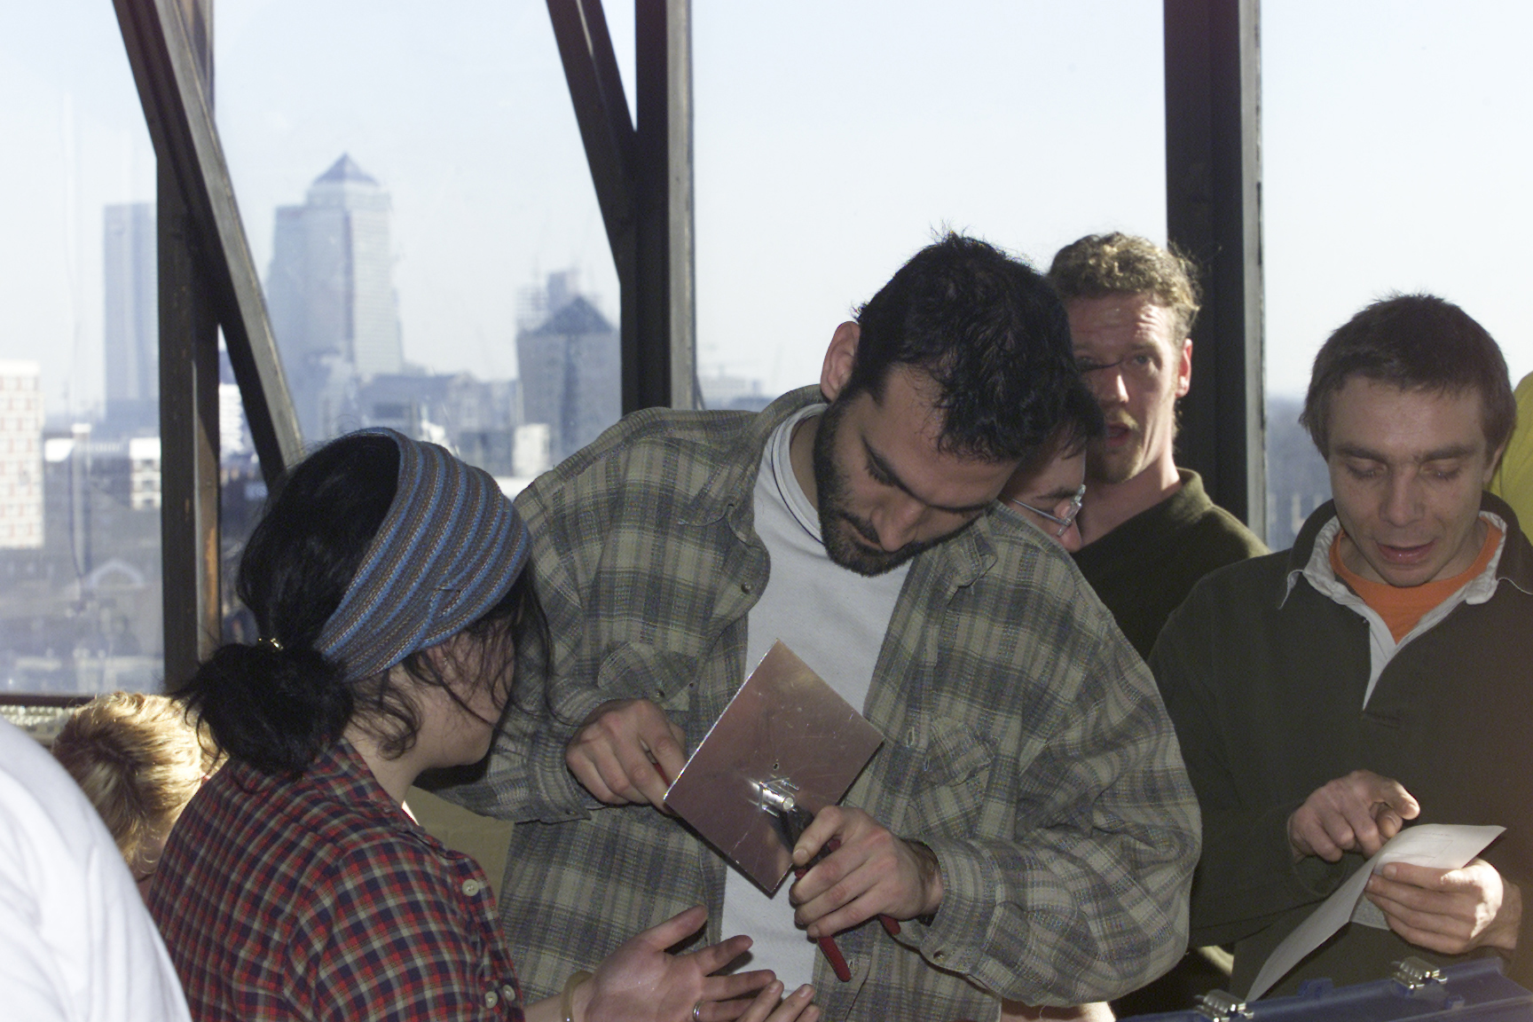Fig. 6. Consume workshop at the studio of AmbientTV.NET, London, circa 2003.

I received an invitation to this workshop and remember that I was electrified (although it turned out that I could not participate in that first meeting). I knew that James Stevens was on to something. As he later put it in his own words, ‘it was on the cusp of a wave of awareness that was sweeping around, also economically we were in a funny state, in a kind of decline of the swell after all of that gluttony of that Dotcom shit.’ Within the space of a few years the Net had been completely transformed from a colorful space dominated by various leftist and creative types to a place apparently ruled and defined by multinational corporations.

The early WWW had generated a lot of enthusiasm about free speech and possibilities of political self-organization. It was seen as an electronic Agora, a place where democracy could be reinvented through participatory processes, electronically mediated. Yet in the eyes of the media, all attention was devoted to internet startups such as Netscape and Amazon who made billions with their IPOs. Ideas about freedom of speech and creative expression, held dear at places such as Backspace, were completely omitted in public discourse. But in late 1999 the stock market boom had started to flounder and in April 2000 the Nasdaq collapsed. Suddenly, the pendulum swung back and ideas about freedom of speech and political self-organization came back. The call for the first Consume workshop was met with *a phenomenal response* according to Stevens. The question they asked themselves was: the technology had shown to work in a relatively confined area. Could it be made to work over a mile or two? Could different areas be connected into a Wide Area Community Network? Stevens:

There was a momentum there, in that way, because it grasped peoples attention and got them to come out, literally, just physically to turn up, gather at a meeting, and really, the second meeting that we had, we built nodes. It was really just like as direct as that: physically turn up and do it; those who could handle the Unix side of it, which is not everybody, obviously.[19]

A subsequent workshop was held sometime in the first half of 2000. What they were out to do, ‘was to provide ownership of network segments to self-provide those services and in addition to that do all sorts of node-to-node kind of benefits’, explained Stevens. But the dynamic IP packet routing required (or meshing) was soon confirmed as a core issue remaining to be solved. The nodes deployed in such a network had to mesh, and this had to be automatic.

This was a grave problem in 2000, since the internet by then had been thoroughly commodified and chunks of it handed over to companies, who could define it as their *country* or Autonomous System, controlling the entry points of their network. This is called Border Gateway Routing Protocol and on such a technical level there is nothing to be said against it. However, it introduces a more distributed hierarchical structure, which helped accommodate rapid connectivity growth of internet networks. A downside of this growth appeared soon after with increasing scarcity for assignment of remaining globally routable IP network numbers. Due to the cascaded nature of networks, with many layers, users in internal networks are often linked via a protocol called NAT (Network Address Translation). That means, that the router controls the global connection to the world, while any node behind it is visible to the world through this gateway alone. In other words, there is no publicly visible route to one’s machine. If a lot of people who share their network connectivity via wireless have such a provider, the routing in the network becomes a problem. There are workarounds for that problem, but this is just one aspect of a protracted sequence of issues regarding wireless routing.[20]

At that point, in the year 2000, mesh networking technology was really in its infancy. Through the launch of Consume, a lot of gifted people started to get interested in mesh networking and similar ideas. It is fair to say that community networks took mesh technology out of the military closet and turned it into a working technology (a story which continues today with great intensity and to which I will return later in this book).

The way Consume grew, initially, owed much more to the special *genius* of James Stevens than to any technology. *Genius*, a term usually reserved for artists or sometimes also scientists, in this context refers to a social skill. James Stevens has a special way of *growing* projects, of initiating them, bringing them into existence but then letting them go their own way. Rather than becoming the leader and figurehead, he tries to initiate a self-perpetuating idea. Maybe this has also something to do with his past in the underground music and squatter scene in the 1980s. Politically, those social scenes were, if not explicitly anarchist, connected with a deep-seated social and artistic liberalism that I found to be much more entrenched in England than in any other country of which I know.

For Stevens and Priest it was a long term goal to ‘find an opportunity, within the legislation of radio spectrum, to use these domestic computer devices to interlink in a way that it was deemed possible to bypass the local loop’, argued Stevens. For him, what became a priority was advocacy, ‘promotion of systems that create a mesh over the topography. […] You just have to propagate the idea or possibility or potential across the landscape.’ And that is what happened in the years 2000 to 2002. While Julian Priest had to take a step back for a little while for private reasons and because of moving to Denmark, James Stevens and a small but fast growing group of volunteers was building Consume, a self-propagating net. A Consume mailing list and a website were launched. But the main mechanism for propagating the idea were workshops. There were a number of workshops in spring and summer of 2002, one at the studio of Manu Luksch and Ilze Black, another one at Limehouse Town Hall, which I remember vividly.

The workshops offered something for everyone. First and foremost, they gave people in a particular area the opportunity to meet and discuss the possibilities of creating a local wireless community network. This involved the social side of getting to know other people in the area. This may not sound like much, but in London talking to neighbors is seen as something quite radical. The only apparently banal thing of *talking to neighbors* went together with exploring the city-scape for suitable locations for antennas and repeaters.

Those who were inclined to do so were building antennas, an activity that showed to be quite attractive for a diverse range of people. It is also something that turns the rather abstract idea of the network into something that can be literally grasped. Antenna building also involves learning about basic physics and the electromagnetic spectrum, which is something very useful in a world pervaded by electronic devices.

Other workshop participants turned to the software side of things. At the time, old computers were used as wireless routers. They were taken apart, reassembled, equipped with network cards, turned into GNU/Linux machines and then configured by usage of some bespoke experimental routing software. The issues that posed themselves with regard to routing and networking were publicly and hotly debated which, in my case, triggered a steep learning curve. This was a time when I started to gain knowledge of IP numbers, address spaces, NATing, and port forwarding, and, last not least, routing protocols.

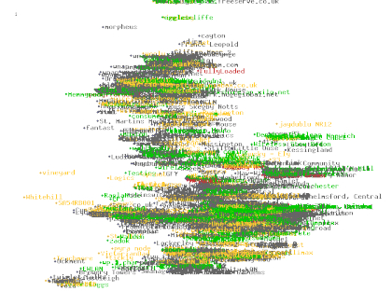Fig. 7. Screenshot of Consume Node Data Base of UK in text mode.

As Stevens and a core group of supporters traveled up and down the country, workshopping, talking, advocating, Consume quickly developed a national dimension. Networks and nodes popped up all over the country. The vibrancy of Consume was based on the support it found by a wide range of people across the UK. Stevens advocated a model of decentralized person to person communication, realized via self-managed nodes. Decentralization was at the core of the idea, politically as well as technologically. The network was not centrally owned and managed but came together as a result of the activities of many independent and self-motivated actors. James Stevens at the time argued:

Creating any sort of infrastructural layer on the landscape, in an environment or the community, that’s something that has always been left to the councils or commercial entities, but this is something that can be pulled out from the ground at any level almost really. A school can just decide to put up an access point: utilize, redistribute, in order to legitimately pass the network that it has got from its council network and say its available throughout the school without any wires.[21]

Stevens wanted to demonstrate that large, infrastructural projects could be realized in a bottom-up manner, through processes of self-organization and through the mobilization of social capital (rather than financial capital). This was only possible because Consume attracted some very gifted people, such as the Russian artist-engineer Alexei Blinov, founder of Raylab, later Hive Networks; hacker-programmer-techies such as Jasper, who programmed the Consume Node data base, and BSD core developer Bruce Simpson; and network admin wizards such as Ten Yen and Ian Morrison. Other people who participated, such as Saul Albert and Simon Worthington, co-founder of Mute Magazine, could be described as non-commercial social entrepreneurs; their strength was also advocacy, creating ideas of their own and pulling in people and resources; the same can be said of artists and curators such as Manu Luksch, Ilze Black and myself who, for a while, also belonged to the core of the London free network scene.[22] Another core participant was Adam Burns, who can claim to have had the same idea, more or less, by himself, and had set up the first wireless free network node in Europe, free2air.org.

## 1.5 You are Free 2 Air Your Opinion

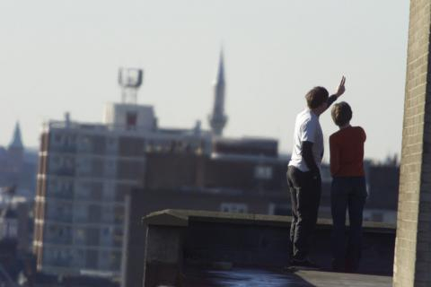Fig. 8. Adam Burns and Manu Luksch explore skies over East London. Photo: Chris Helgren.

While Consume had been an early project, as a really existing free network in London it had been preceded by free2air.org. Free2air.org was the virtual flag flown by Adam Burns, of Australian descent. In his daytime job he managed firewalls of financial groups, in his spare time he had set up an omni-directional antenna on a building on Hackney Road, just above the Bus stop and a Halal Chicken shop. From there, everybody could pick up a signal who was within range.

To my knowledge I am not aware of any other facility in Europe offering totally open network access like this. I do not want to know the name, the address, the credit card number, the color of the eyes or hair of anyone who connects through to this network. That’s unimportant to me, and I don’t feel that this is a necessary requirement.[23]

At the time of the interview, in autumn 2002, Adam Burns claimed that free2air had been active for 18 months. Thus, from late 1999 or early 2000, free2air.org, hosted on a machine called Ground Zero, offered free wireless internet access to everyone passing through. Adam Burns had been involved with early ISPs in Australia in the early 1990s, providing internet access more out of ethical conviction than business sense. This background has inspired his keen sense of networking as a social project.

free2air is a contentious name, but one that I have chosen to use. Basically it has a dual meaning: once you establish such a network the cost of information travel is free. It’s not a totally free service to establish, you need to buy hardware, you need computer expertise and so on. But the whole idea of ongoing costs are minimal. Secondly, what I liked about it is the plans for a distributed open public access network. It gets rid of the idea of a central ISP, in other words, globally around the world, when we are talking about the internet rather than censorship or pedophiles hanging out, or bomb makers, there is a lot of concentration on what really goes on in networks. When you have got a lot of people passing information directly to each other its very hard to track down what information has and has not passed and how it got aired. So there is a double meaning to free2air, it also means you are free to air your expressions without concern or problems in getting that message through.[24]

## 1.6 East End Net

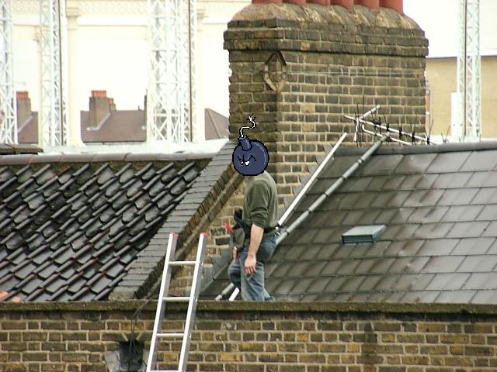Fig. 9. Free2air's node groundzero gets an antenna upgrade circa 2002.

Adam Burns became a central person in the London wireless scene around Consume and what came to be known as East End Net. The idea was launched to connect Limehouse Town Hall with the area around the office of Mute magazine at lower Brick Lane, and somehow to connect also Bethnal Green and central Hackney. That bit was also the place where I lived at the time. While the large version of East End Net never materialized, we had our local version of it, with a connection from free2air.org to the *compound*, a large workspace building for small industries at the bottom of Broadway Market in E8.

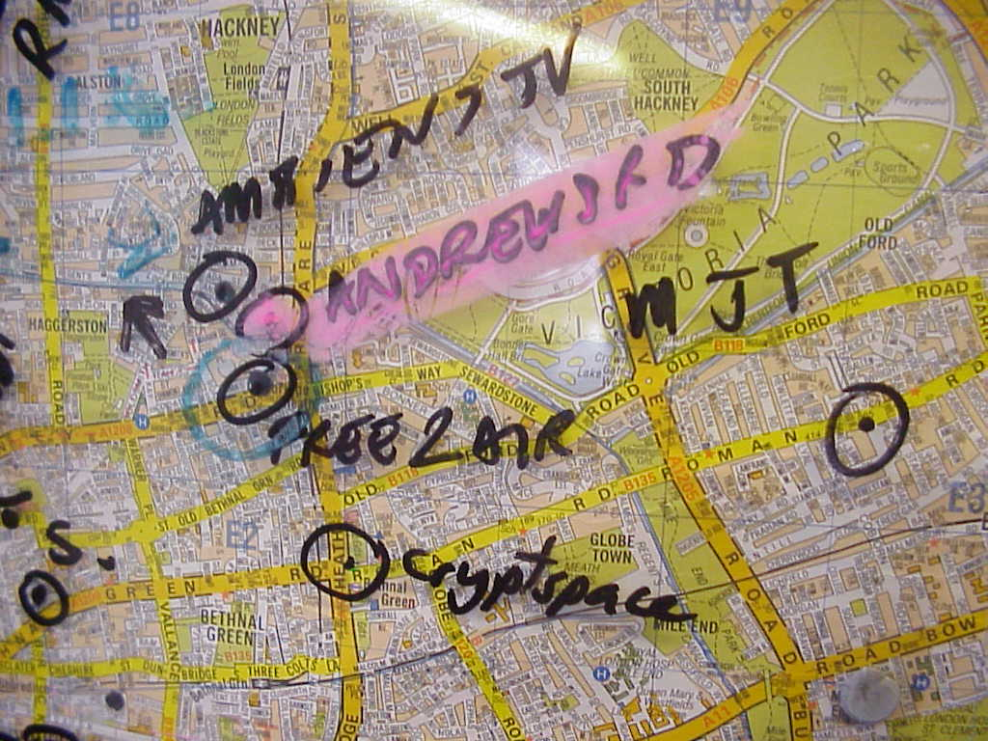Fig. 10. East End Net: The Original Map.

With AmbientTV.net’s help, the connection was spread by wireless and wirebound throughout the building. For several years a community of changing size, from between 20 to 40 or 60 people, inhabited a chunk of the net. Due to the social composition of this area, a number of art projects using the free WLAN took place. I will turn to those projects at a later stage.

While East End Net was never built in the way it was supposed to, the discussions and the focus that it generated was highly productive in a number of areas. Several lines of flight are taking off from this point, which all will have to be followed separately – so I will just hint at some of those ideas in overview form. The hand drawn original map of East End Net was the starting point for a lot of ideas about mapping of wireless networks, but also ideas about communal map making as such. It was the time when the Open Street Map project began, as it was recognized that also something as complex as a map could be built in a decentralized way by unpaid volunteers.

Consume’s NodeDB, as already mentioned, was a quite early and successful attempt at building a website that facilitates registering a free network node through a wiki-like functionality. The idea was that the database would not only contain technical information about nodes, but also additional information about services offered. In this way, the NOdeDB would become the focus of community development and of micro-ecologies of small business, art, culture, activism.

The communal building of a wireless mesh network over a large part of a metropolitan area also raised issues about ownership and responsibility. While, as we shall see, in Germany the discussion from the very start was dominated by anxiety about legal repercussions of sharing an internet connection, in London the discussion was about the notion of the commons. It was through Julian Priest that I became introduced to the work of Elinor Ostrom who successfully contested the hegemony of the thesis of the Tragedy of the Commons – work for which she later received the Nobel price in economics. We started to discuss the implications of what it means to treat the network as a commons and sought to find ways of affirming this status of the network commons.

For me, personally, two fundamental insights emerged from my involvement at the time. Through participating in workshops and talking to techies, I started to understand a bit more what happened behind the surface of the screen when one clicks on a webpage or sends an email. As I gained insight into how networks function technically, I experienced this as a form of empowerment. In my view, everyone should understand at least a little bit how networks work. Why? Because networking is not just about moving around bits and bytes, it is about communication, freedom of speech, about democratic participation, the freedom to learn things. One big problem that we have in societies such as ours is that the division of labor imposed on us creates categorical separations between things that should be seen and understood as belonging together. Building and maintaining telecommunication networks is seen as a technical task but affects fundamental human rights and social issues. Thus, everybody should have at least some idea about how it works, as one otherwise cannot meaningfully participate in Network Society.

Thus, as a grand thesis I would like to introduce here, I propose that the involvement of ordinary people in building a network commons has a profound emancipatory effect. In particular, as the process allows people to learn more about the structure and the functioning of the internet, they gain a better understanding of what they can potentially achieve in societies and, no less important, how to protect themselves from the harmful effects of information abuse by corporations and government. As people learn how networks work they can become teachers of the free network spirit. They will understand that they can become part of the network (and not only be users of a service provided by a corporation or the state) and can bring to it their own specializations and ideas. Through that, the idea of the network also gets enriched.

Thus, the second part of the thesis is that free networks contribute to the democratization of technology. Conventionally, technology is considered to be developed behind the closed walls of research labs. There, gods in white (or jeans and black polo-neck sweater) develop the technologies of the futures, which the thankful people then consume as a commodity. The way in which wireless community networks function, that is, the development of cutting edge technology, is opened up to wider mechanisms of participation. This second part of the thesis is almost confirmed already through the existence of projects such as the EU project Confine. Through the involvement of community networkers in shaping future technologies, those technologies become less elitist, less controlled by narrow commercial or security interest. The original peer-to-peer spirit of the Net gets enhanced and made fit for the future in a network commons that is there to protect our democratic freedoms and rights.[25]

1. Armin Medosch, Freie Netze. Geschichte, Politik und Kultur offener WLAN-Netze, Heise Verlag, Hannover 2004, https://ftp.heise.de/tp/buch_11.pdf.
2. Confine Project (2012-2015), archived October 2015, https://web.archive.org/web/20151003180403/https://www.confine-project.eu/.
3. Armin Medosch, Freie Netze. Geschichte, Politik und Kultur offener WLAN-Netze, Heise Verlag, Hannover 2004, https://ftp.heise.de/tp/buch_11.pdf.
4. Volker Grassmuck, Freie Software. Zwischen Privat- und Gemeineigentum, Bundeszentrale für politische Bildung, 2. Auflage 2004, https://freie-software.bpb.de/Grassmuck.pdf.
5. GNU General Public License (GPL), https://www.gnu.org/licenses/licenses.html.
6. OpenWrt: 4G Systems MTX-1 MeshCube / AccessCube, https://openwrt.org/toh/4g.systems/access.cube.
7. Wikipedia: http://en.wikipedia.org/wiki/Dispositif. The same Wikipedia page further defines the dispositif as ‘the interaction of discursive behavior (i. e. speech and thoughts based upon a shared knowledge pool), non-discursive behavior (i. e. acts based upon knowledge), and manifestations of knowledge by means of acts or behaviors [...]. Dispositifs can thus be imagined as a kind of Gesamtkunstwerk, the complexly interwoven and integrated dispositifs add up in their entirety to a dispositif of all society.’ (quoted from Siegfried Jäger: Theoretische und methodische Aspekte einer Kritischen Diskurs- und Dispositivanalyse http://www.diss-duisburg.de/Internetbibliothek/Artikel/Aspekte_einer_Kritischen_Diskursanalyse.htm).
8. Allucquère Rosanne Stone, The War of Desire and Technology at the Close of the Mechanical Age. MIT Press, 1996.
9. Howard Rheingold, The Virtual Community: Homesteading on the Electronic Frontier. MIT Press, 1993.
10. Heidi Grundmann, Art + Telecommunication. Vancouver, B.C.: Western Front Publication, 1984.
11. Roy Ascot 1984, quoted in Grundmann 1984, p. 28.
12. Olia Lialina, *Some Universe*, [http://art.teleportacia.org/exhibition/stellastar/](https://web.archive.org/web/20150520012157/http://art.teleportacia.org/exhibition/stellastar/).
13. I have written more extensively about this in Medosch, Armin. *Kreative Milieus*. In *Vergessene Zukunft: Radikale Netzkulturen in Europa*, 1. Aufl., pp. 19–26. Bielefeld: Transcript, 2012.
14. James Stevens, interview with the author, June 2003, private notes.
15. Backspace, http://bak.spc.org/.
16. *Anti with E* conferences and lectures, http://www.irational.org/cybercafe/backspace/.
17. See article by Josephine Berry, Captain's Mate D'Angelo In Interview with intergalactic hack Josephine Berry aboard Starship Backspace, 07 August1998, archived July 2003, https://web.archive.org/web/20030704110709/http://www.medialounge.net/lounge/workspace/crashhtml/cc/23.htm.
18. See History of Wi-Fi: Wolter Lemstra, Vic Hayes and John Groenewegen, The Innovation Journey of Wi-Fi: The Road to Global Success. Cambridge University Press, 2010.
19. James Stevens, interview with the author, June 2003, private notes.
20. Corinna *Elektra* Aichele, a free networker from Berlin, has summed up those problems and possible solutions much better than I ever could in her book *Mesh – Drahtlose Ad-hoc Netze*, Open Source Verlag, 2007, https://download-master.berlin.freifunk.net/ebooks/mesh_kapitel4_leseprobe.pdf.
21. James Stevens, interview with the author, June 2003, private notes.
22. Here, the original text said: “(I will dedicate a special chapter to art and wireless community networks later in this book)”, which might have been a note of the author to himself that ended up unrealized.
23. Adam Burns, Interview with Armin Medosch, Autumn 2002.
24. Adam Burns, Interview with Armin Medosch, Autumn 2002.
25. Related links:

    Guifi: https://guifi.net/

    Freifunk: https://freifunk.net/

    Confine Project (2012-2015), archived October 2015, https://web.archive.org/web/20151003180403/https://www.confine-project.eu/.

    Art Servers Unlimited: https://monoskop.org/Art_Servers_Unlimited.